贵州黔东南州2017年小学升学文化水平统一检测
英语试卷（湘少版）
听力部分（30分）
一、听录音，根据所听到的录音，从方框中选出相对应的字母组合，并写在横线上。每 小题读两遍。（5分）
ay ee all dr br

1. 2. 3. 4. 5.
二、听录音，选出你所听到的单词。每小题读两遍。（5分）
( )1.A.wood B.good C.cook
( )2.A.meat B.easy C.season
( )3.A.place B.space C.face
( )4.A.think B.thank C.drink
( )5.A.classes B.buses C.glasses
三、听问句，选答句。每小题读两遍。（10分）
( )1.A.We’ll watch a movie. B.We’ll go to Guiyang.
( )2.A.My family will go to the park next weekend.
B.My family usually goes to the park at weekend.
( )3.A.He likes science books. B.She likes fairy tales.
( )4.A.It has water and land. B.It looks like a ball.
( )5.A.Because the tress can keep the air clean.
B.We can plant trees on the roads.
四、听录音，根据录音内容判断句子正(T)误(F)。每小题读两遍。（10分）
( )1.She sang and danced.
( )2.Dongdong can’t swim.
( )3.Tomorrow is on June 1st.
( )4.John’s cap is red.Benny’s cap is yellow.
( )5.Today is Tom’s birthday.
笔试部分（70分）
一、选出下列划线部分读音不同的一项。（5分）
( )1.A.six B.fit C.like
( )2.A.up B.difficult C.cut
( )3.A.lose B.space C.cross
( )4.A.party B.reply C.sandy
( )5.A.black B.climb C.building
二、根据图片或句意填单词。每空一词，注意词形的变化。（10分）
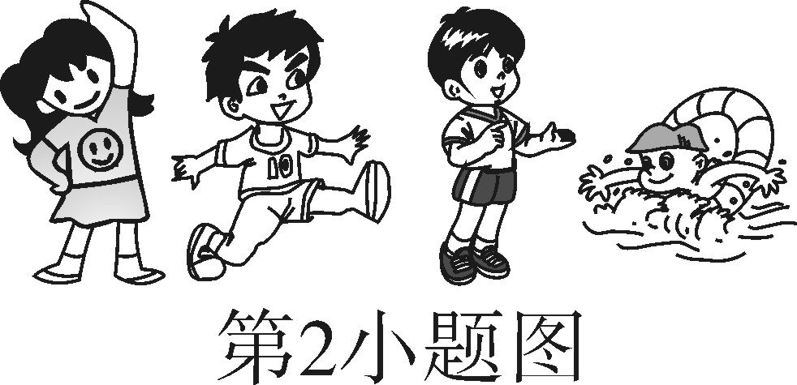
1. is in London.It’s very old.But the clock is still working.(此题填两个词)
2.We should do every day.We can be strong.
3.My family likes .My family went to the USA last winter.
4.We should eat food.We should eat vegetable,fish and fruit.
5.—Did your dad work very late last night?
—Yes,he felt very .
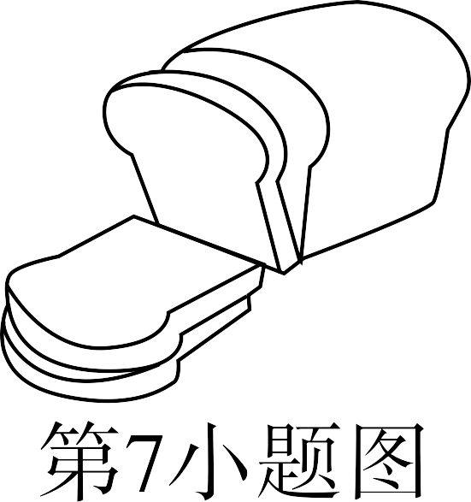
6.Dongdong can’t read this book.It’s too for him.
7.That piece of is bigger.
8. trees is good for us.
9.I’m cold.Please the door.
10.My mother’s father and mother are my .
三、用所给词的适当形式填空。（15分）
1.We should wash our hands before (eat).
2.My sister is (tall)than me.
3.We (play)basketball together tomorrow.
4.My family (not like)to play on the beach.
5.I think storybooks are (interesting)than picture books.
6.They enjoyed (listen)to music.
7.I (take)many (picture)in Guizhou last year.
8.Trees can keep (we)cool and (make)the place beautiful.
9.Peter wanted (fly)a kite on the mountain with his friends.
10.He lives with his family (happy).
11.Where (do)your family go last year?
12.We (be)not afraid of dogs.
13.Ann stepped on (Lingling)foot.
四、补全对话。（10分）
Lisa:Hi,Mike.How are you?
A.I have a bad headache.
B.I hope you’ll feel better soon.
C.What did the doctor say?
D.Not very well.
E.Did you go to see a doctor?

Mike: 1
Lisa:Oh,What’s wrong with you?
Mike: 2
Lisa:I am sorry to hear that. 3
Mike:Yes,I did.
Lisa: 4
Mike:Take some medicine and stay at home.
Lisa: 5
Mike:Thank you.
五、阅读理解。(20分)
（一）阅读短文，给下面的图片排序。（10分）
Last summer I learned how to swim.First,the teacher told me to hold my breath.Then I learned to put my head under water.I practiced kicking my feet.While I held on to a float, I paddled around the pool.Next,I floated to my teacher with my arms straight out. Finally, I swam using both my arms and my legs.I did it!Swimming is fun!
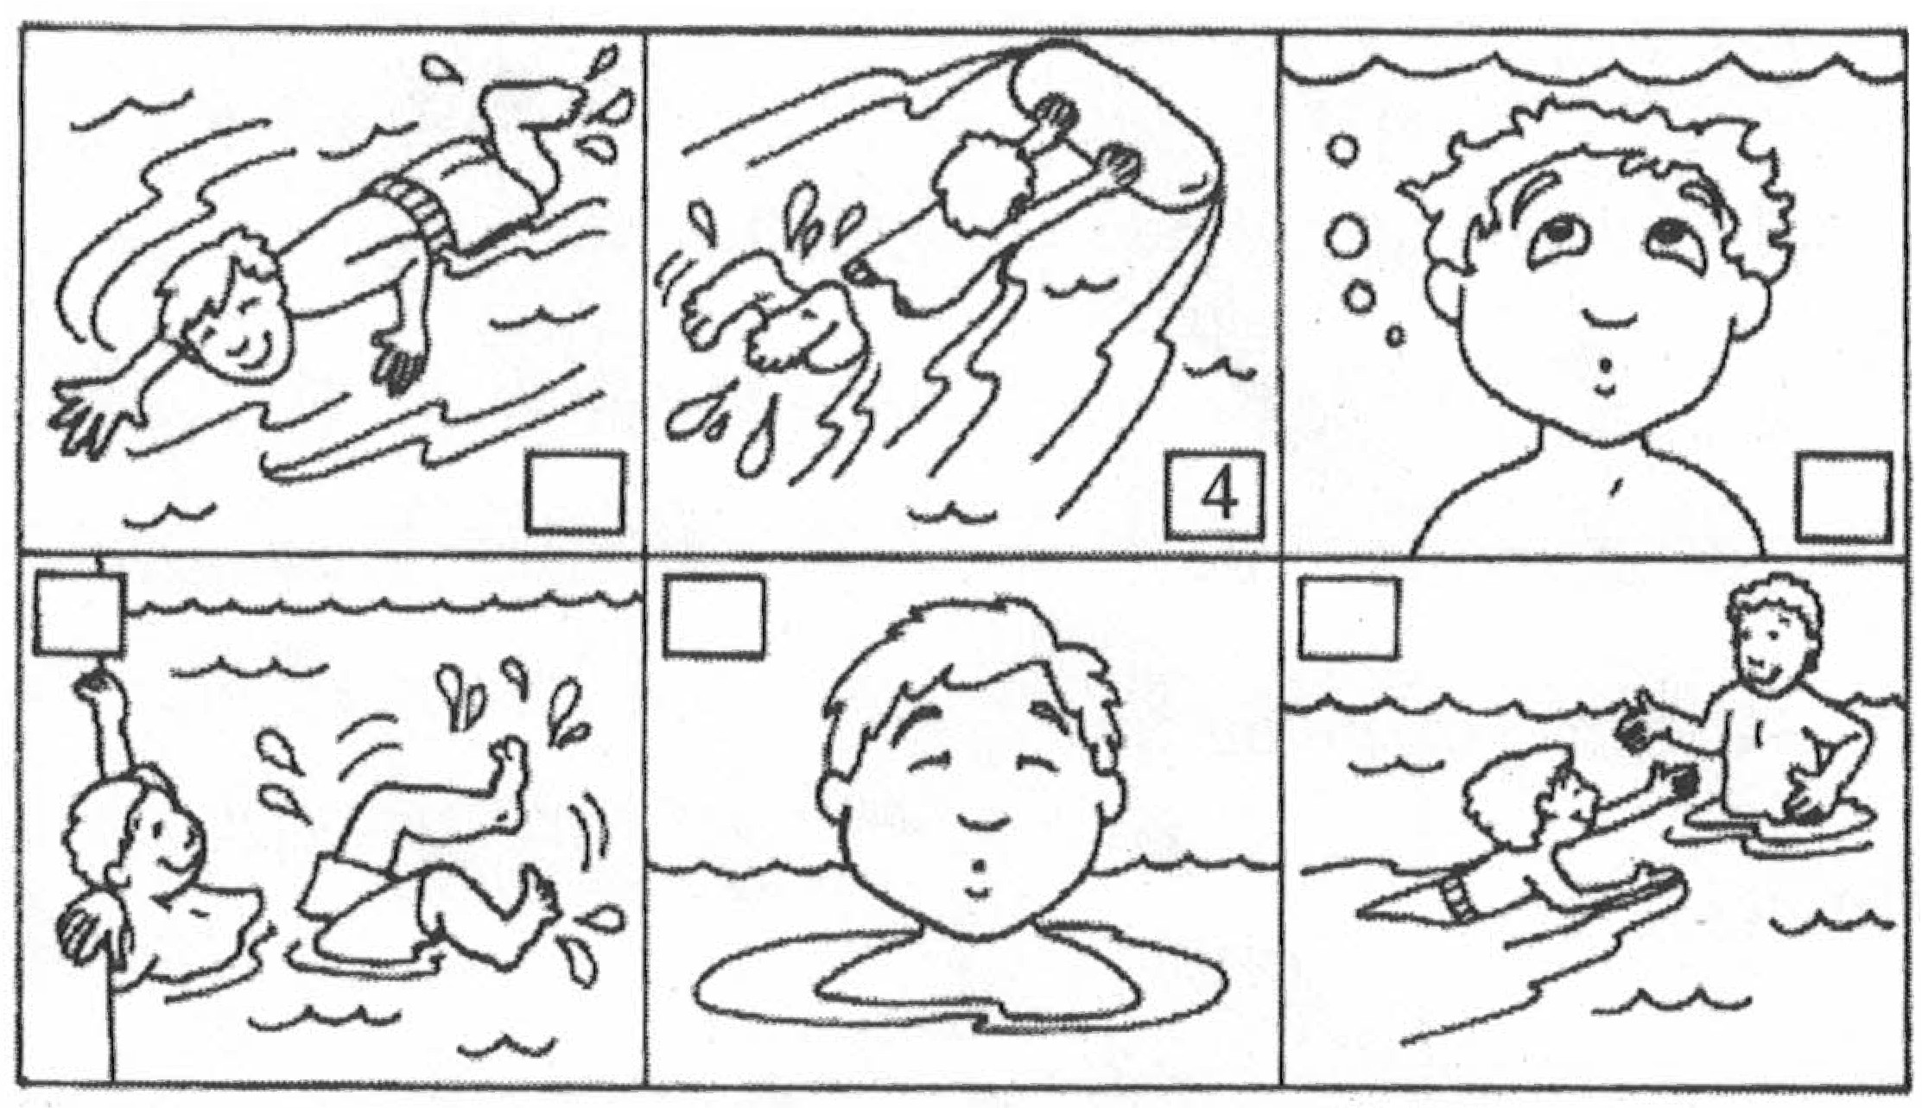
（二）阅读短文，从ABC中选出最佳答案。（10分）
A cat goes to a river every day.He wants to go fishing.But he can’t catch any fish.One day,he goes to the river as usual.Suddenly,a fish comes out.He catches the fish.He is very happy.He forgets to put the fish in the basket.He dances and sings.He shouts,“I have a fish!I have a fish!” All his friends come to see him.“Where is your fish? Let’s have a look at it.” his friends say. But he can’t find the fish.When he sings and dances,the fish jumps back into the river. The cat is very sad.
( )1.The cat goes to the river every day to .
A.catch fish B.eat fish C.play
( )2.One day,a fish comes out and the cat .
A.eats it B.catches it C.lets it go
( )3.The cat’s friends come to see the fish,but they .
A.don’t see any fish B.see a small fish C.see a big fish
( )4.Where is the fish at last?
A.In the basket. B.In the river. C.In the cat’s mouth.
( )5.The cat is very ,because the fish jumps back into the river.
A.happy B.worried C.sad
六、小作文。(10分)
暑假生活马上就要开始了，请根据下面的问题写一篇小短文。
l.Where are you going on your holiday?
2.When are you going?
3.How are you going to get there?
4.Who are you going with?
5.What are you going to do there?
要求：1.条理清楚，意思连贯，语句通顺。
2.书写清晰、规范，标点正确。
3.至少写5句话，50个单词左右。

贵州黔东南州2017年小学升学文化水平统一检测
英语试卷（湘少版）

笔试部分
一、1—5 CBABB
二、1.Big Ben 2.exercise 3.traveling 4.healthy 5.tired 6.difficult 7.bread 8.Planting 9.close 10.grandparents
三、1.eating 2.taller 3.will play/are going to play 4.doesn’t like 5.more interesting 6.listening 7.took;pictures 8.our;make 9.to fly 10.happily 11.did 12.are 13.Lingling’s
四、1—5 DAECB
五、（一）6 4 2 3 1 5
（二）ABABC
六、作文
Summer holiday is coming.I like summer holiday very much.I am going to visit my grandma because I miss her very much.She lives in Beijing and I will get there by plane.My parents and my sister will go with me.We will visit the Great Wall and eat many delicious food there. We will have a good time.

