黄州区小学六年级毕业考试
考点 考场 姓名___________ 考号
……………………………密………………………………………封…………………………………线……………………………
英语试卷
（时间：60分钟 满分：100分）
Listening Part 听力部分（共40分）
一、听录音，选择你所听到的单词，将序号填在括号里。（10分）
（ ）1.A.library B.cinema C.museum
（ ）2.A.cool B.warm C.hot
（ ）3.A.went B.got C.had
（ ）4.A.study B.studies C.studied
（ ）5.A.coat B.count C.coach
（ ）6.A.worried B.worry C.wrong
（ ）7.A.season B.second C.sometimes
（ ）8.A.thinner B.heavier C.bigger
（ ）9.A.August B.October C.April
（ ）10.A.fourth B.fifth C.first
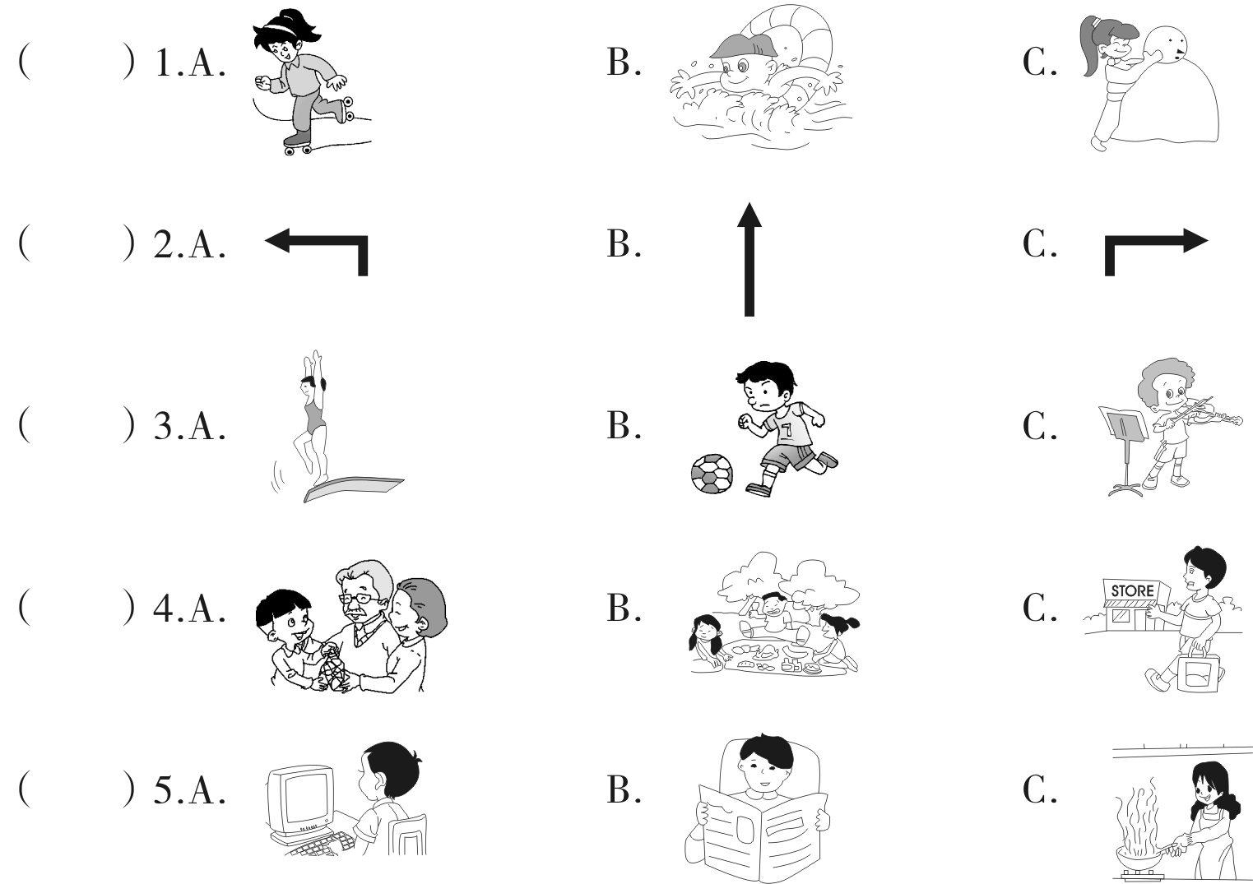
二、听录音，选择你所听到的图片，将序号填在括号里。（10分）

三、听录音，判断下列句子与你所听到的内容是否相符，相符的打“√”，不相符的打“×”。（10分）
（ ）1.Sarah likes winter best.
（ ）2.The students went to the zoo with their teachers yesterday.
（ ）3.My mother is a doctor.
（ ）4.Mr Smith is in the bathroom.
（ ）5.The carrots are under the chair.
四、听短文，判断下列句子与短文内容是否相符，相符的在括号里写“T”，不相符的写“F”。（10分）
（ ）1.Liu Ming has a sister.
（ ）2.Liu Ming and Liu Fen are not in the same school.
（ ）3.Liu Ming likes music very much.
（ ）4.Liu Fen likes playing computer games.
（ ）5.There are forty computers in the computer room.

Writing Part 笔试部分 (共60分)
五、看图，选择正确的单词或短语，将序号填在各自对应的括号里。（5分）
A.climbed a mountain B.postcard C.bought presents
D.happy E.see a film

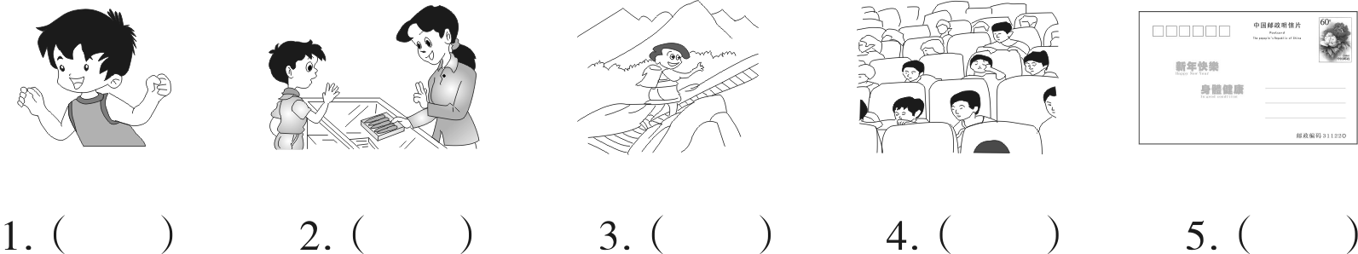

六、选择正确的答案，将序号填在括号里。（5分）
（ ）1.An elephant is than a cat.
A.longer B.bigger C.smaller
（ ）2.Stop at a light.
A.red B.yellow C.green
（ ）3.—When is Teachers’ Day?
— .
A.Oct.1st B.Sept.10th C.Jun. 1st
（ ）4.There a big desk,two beds and three chairs in my room.
A.is B.are C.am
（ ）5.— is it?
—Fifty yuan.
A.How many B.How much C.How old
七、从Ⅱ栏中找出Ⅰ栏句子的答语，将序号填在括号里。（10分）
Ⅰ Ⅱ
（ ）1.How does Lisa feel? A.He is a pilot.
（ ）2.What did you do last weekend? B.He goes by bike.
（ ）3.Did you read books? C.No,it isn’t.It’s in November.
（ ）4.Is your birthday in December? D.I played football.
（ ）5.What does your uncle do? E.It’s March 8th.
（ ）6.When is your birthday? F.Yes,I did.
（ ）7.What is Amy doing? G.It’s cloudy.
（ ）8.What’s your hobby? H.She feels tired.
（ ）9.What’s the weather like today? I.She is playing the pipa.
（ ）10.How does he visit his grandparents? J.I like making kites.
八、用所给词的正确形式填空。（10分）
short dance sheep see snow
1.Look!Amy is in the party.
2.It’s a day today.
3.She monkeys in the zoo yesterday.
4.There are thirty on the farm.
5.I’m than my father.
九、连词成句，注意大小写和标点符号。（10分）
1.look you happy so (.)
2.clean can I room the (.)
3.how there horses are many (?)
4.older I am you than year one (.)
5.there a bridge is the in park (?)

十、选择相应的句子完成对话，将序号填在横线上。（10分）
A.Did you go to see the doctor? B.What are you going to do there?
C.How are you going there? D.No,sorry.
E.What’s wrong?

A:1.
B:I am ill.
A:2.
B:Yes,I went to see the doctor.He told me to take some medicine.
A:We’re going to a park.Are you going with me?
B:3. I will stay at home.
A:That’s fine.
B:4.
A:We are going to have a picnic.
B:5.
A:We are going there by bus.
十一、阅读短文，判断下列句子正（T）误（F）。（10分）
Last weekend we had a birthday party for Zhang Li.She is younger than me,but I am shorter than her.I went to a shop to buy a storybook for Zhang Li.Because she likes reading.Then we went boating in Daming Park.We had a good time on that day.
（ ）1.Zhang Li is taller and younger than me.
（ ）2.I am thinner than Zhang Li.
（ ）3.I bought a ball for Zhang Li.
（ ）4.We went swimming and went boating in the park.
（ ）5.They had a good time on Zhang Li’s birthday.
黄州区小学六年级毕业考试
笔试部分参考答案

五、1—5 DCAEB
六、1—5 BABAB
七、1—5 HDFCA 6—10 EIJGB
八、1.dancing 2.snowy 3.saw 4.sheep 5.shorter
九、1.You look so happy.
2.I can clean the room.
3.How many horses are there?
4.I am one year older than you.
5.Is there a bridge in the park?
十、1—5EADBC
十一、1—5 TFFFT

