**2015年普通高等学校招生全国统一考试（湖南卷）**

**英 语**

**本试卷分为四个部分，共12页。时量120分钟。满分150分**

**PartⅠ Listening Comprehension (30 marks)**

**Section A （22.5 marks）**

***Directions: In this section, you will hear six conversations between two speakers. For each conversation, there are several questions and each question is followed by three choices marked A, B and C. Listen carefully and then choose the best answer for each question.***

**You will hear each conversation *TWICE.***

***Example：***

When will the magazine probably arrive？

A.Wednesday. B.Thursday C.Friday.

***The answer is B.***

***Conversation 1***

1. When does the woman usually get home from work?

A. About 6:30. B. About 7:30. C. About 8:30.

2. What did the woman do last night?

A. She watched TV.

B. She recorded a program.

C. She prepared for a lecture.

***Conversation 2***

3. How often does the man exercise at the gym?

A. Every day. B. Every two days. C. Once a week.

4. Where will the two speakers meet before doing exercise this Friday?

A. At the park. B. At the cafe. C. At the cinema.

***Conversation 3***

5. What is Mr. Chester doing?

A. Telephoning someone.

B. Speaking to the woman.

C. Leaving the man a message.

6. What is the man's last name?

A. Oliver. B. Horst. C. Robert.

***Conversation 4***

7. Why will the woman be late?

A. She didn't catch the train.

B. She didn't finish her paper.

C. She didn't wake up in time.

8. Where is the man?

A. At the station. B. At home. C. At the office.

9. What is the probable relationship between the two speakers?

A. Teacher and student. B. Parent and child. C. Husband and wife.

***Conversation 5***

10. For whom does the woman buy the T-shirt?

A. Herself. B. Her husband. C. Her friend.

11 .How much does the T-shirt normally cost?

A. $54. B. $60. C. $70.

12. Why does the salesman agree to sell the T-shirt at $48?

A. It is cheaper online. B. He is in a hurry. C. A button is lost.

***Conversation 6***

13. When did the woman arrive?

A. Friday. B. Saturday. C. Sunday.

14. What major did the man choose in the end?

A. English. B. Biology. C . History.

15. What suggestion does the man give on reading the books?

A. Making notes. B. Skimming first. C. Reading word by word.

**Section B（7.5 marks）**

***Directions: In this section, you will hear a short passage. Listen carefully and then fill in the numbered blanks with the information you have heard. Fill in each blank with NO MORE THAN THREE WORDS.***

***You will hear the short passage******TWICE***

|  |
| --- |
| **School Web Design**  16  I. Meet on 17 from 2:30 to 3:15  II. Create a website for a competition  ● Website  **☆** on your ancestor 18  **☆** 19 long & well constructed  ● Competition  **☆** has a first prize of $300 for beginners & $ 20 for the advanced  **☆** do it by yourself, list the software you used |

**Part Ⅱ Language Knowledge (45 marks)**

**Section A (15 marks)**

***Directions: For each of the following unfinished sentences there are four choices marked A, B, C and D. Choose the one that best completes the sentence.***

***Example：***

The wild flowers looked like a soft orange blanket ________ the desert.

A . covering B.covered C.cover D.to cover

***The answer is A.***

21.It was when we were returning home ________ I realized what a good feeling it was to have helped someone in trouble.

A. which B. that C. where D. how

22. As you go through this book, you ________ that each of the millions of people who lived through World War II had a different experience.

A. will find B. found C. had found D. have found

23. Only after talking to two students ________ that having strong motivation is one of the biggest factors in reaching goals.

A. I did discover B. did I discover C. I discovered D. discovered I

24. Video games can be a poor influence if ________ in the wrong hands.

A. to leave B. leaving C. leave D. left

25. I wasn't able to hide my eagerness when I ________, "What do you wish me to do now?"

A. ask B. have asked C. am asking D. asked

26. You have to know ________ you're going if you are to plan the best way of getting there.

A. what B. that C. where D. who

27. It is important to remember that success ________ a sum of small efforts made each day and often ________ years of achieve.

A. is; takes B. are; takes C. are; take D. is; take

28. He must have sensed that I ________ him. He suddenly glanced at me and said quietly, "Why are you staring at me like that?"

A. would look at B. looked at C. was looking at D. am looking at

29.It is a truly delightful place, ________ looks the same as it must have done 100 years ago with its winding streets and pretty cottages..

A. as B. where C. that D. which

30. When the clerk saw a kind of face wrinkled in an apologetic smile, she stood rooted to the ground, _________ whether to stay or leave.

A. wondering     B. wonder    C. to wonder   D. wondered

31.Always_______ in mind that your main task is to get this company running smoothly

A. to keep B. to have kept C. keep D. have kept

32.I had a strong desire to reach in and play with the toy,but_______ thankfully by the shop window

A. am held back B. held back C. hold back D. was held back

33._______ the job takes a significant amount of time. most students agree that the experience is worth it A. If only B. After C. Although D. In case

34. Sometimes I act as listening ear for fellow students _______ what is bothering them

A. to talk over B. talked over C. talk over D.having talked over

35.That is why I help brighten people’s days. If you _______ , who’s to say that another person will?

A. did not B. do not C. were not D. have not

**Section B (18 marks)**

***Directions: For each blank in the following passage there are four words or phrases marked A, B, C and D. Fill in each blank with the word or phrase that best fits the context.***

It was a rainy morning and the children, mainly boys with various learning difficulties, refused to settle for the start of the lesson. As an inexperienced teacher, I tried every means to get them to be 36 , but in vain. My panic was rising and I could feel my heart beating wildly. This was the 37 of my job as a music teacher, I thought -- teaching was not for me. Then I had an idea. Hoping that no one would notice that I was 38 inside, I threw my voice as far as it would reach: "Put your heads on the desks and close your 39 ! We are going on a journey."

40 , the children fell silent. "Now what should I do?" I thought to myself. Reaching over to my collection of CDs, I blindly 41 , put it in the machine and played it.

Obediently (顺从地), my class lay their heads on their desks, closed their eyes and 42 . When the music started, the room was filled with the most beautiful tones and musical colors I could have ever imagined. All the children were 43 . When the music finished, I asked them all to raise their 44 slowly so that we could share our musical journeys.

At this point, when all the children were willing to share their experiences, I began to learn how to 45 . The music allowed me to learn that teaching is about sharing and respect, tears and smiles, the knowing and the 46 and,most of all, an understanding of each other. This was the power that 47 in the classroom could have.

36. A. glad B. safe C. kind D. quiet

37.A. end B. aim C. rule D. plan

38. A. guessing B. shaking C. responding D. laughing

39. A. eyes B. mouths C. books D. doors

40. A. Punctually B. Importantly C. Amazingly D. Obviously

41. A. passed one on B. gave one back C. turned one in D. took one out

42. A. slept B. nodded C. waited D. continued

43. A. talking B. singing C. dancing D. listening

44. A. legs B. heads C. arms D. shoulders

45. A. teach B. imagine C. play D. understand

46. A. unprepared B. unspoken C. unknown D. unforgotten

47. A. games B. music C. tears D. knowledge

**Section C (12 marks)**

***Directions: Complete the following passage by filling in each blank with one word that best fits the context.***

Research has become both simpler and more complex. It's simpler because, 48 if you have a computer, you can find information you need by searching the Internet. For all your information, you don't have to go to 49 library to find the relevant resource and take notes on it. Instead, you can find some sources from the Internet 50 print the copies needed. Remember, however, that you should usually consult different types of sources. That is, you 51 always rely just on the Internet for you research.

While finding information is easier than ever, at the same time, researching has become 52 complex. There is a lot more material available, which means you may be overwhelmed 53 the amount of information. You need to learn 54 to sort through and find the relevant information for your particular project. Also, 5547 need to check the accuracy of it.

**Part Ⅲ Reading Comprehension (30 marks)**

***Directions: Read the following three passages. Each passage is followed by several questions or unfinished statements. For each of them there are four choices marked A. B. C and D. Choose the one that fits best according to the information given in the passage.***

**A**

|  |
| --- |
| Forget Cyclists, Pedestrians are Real Danger  *We are having a debate about this topic. Here are some letters from our readers.*  ■Yes, many cyclists behave dangerously. Many drivers are disrespectful of cyclists. But pedestrians are probably the worse offenders.  People of all ages happily walk along the pavement with eyes and hands glued to the mobile phone, quite unaware of what is going on around them. They may even do the same thing while crossing a road at a pedestrian crossing or elsewhere. The rest of us have to evade (避让) them or just stand still to wait for the unavoidable collision.  The real problem is that some pedestrians seem to be, at least for the moment, in worlds of their own that are, to them, much more important than the welfare of others.  ——Michael Horan  ■I loved the letter from Bob Brooks about cyclists (*Viewpoints, May 29*). I am afraid they seem to think they own the roads.  I was walking across Altrincham Road one morning when a cyclist went round me and on being asked what he was doing he shouted at me.  The government built a cycle lane on the road but it is hardly used.  The police do nothing. What a laugh they are!  The cyclists should all have to be made to use the cycle lanes and wear helmets, fluorescent (发荧光的) jackets and lights at night and in the morning. They should pay some sort of tax and be fined for not wearing them.  ——Carol Harvey  ■Cyclists jump on and off pavements (which are meant for pedestrians), ride at speed along the pavements, and think they have a special right to go through traffic lights when they are on red.  I was almost knocked down recently by a cyclist riding on the pavement when there was a cycle lane right next to him.  Other road users, including horse riders, manage to obey the rules so why not cyclists?  It's about time they had to be registered and insured, so when they do hit a pedestrian or a vehicle, or cause an accident, at least **they** can be treated and there might be an opportunity to claim.  ——JML  *Write to* ***Viewpoints*** *of the newspaper.* |

56. Michael Horan wrote the letter mainly to show that _______.

A. drivers should be polite to cyclists

B. road accidents can actually be avoided

C. some pedestrians are a threat to road safety

D. walking while using phones hurts one's eyes

57. Carol Harvey suggests that cyclists should _______.

A. be provided with enough roads

B. be asked to ride on their own lanes

C. be made to pay less tax for cycling

D. be fined for laughing at policemen

58. What is a complaint of JML?

A. Very few drivers are insured.

B. Cyclists ride fast on pavements.

C. Pedestrians go through red traffic lights.

D. Horse riders disrespect other road users.

59. The underlined word "they" in the third letter refers to ______.

A. accidents B. vehicles

C. pedestrians D. cyclists

60. The three letters present viewpoints on _______.

A. real source of road danger

B. ways to improve road facilities

C. measures to punish road offences

D. increased awareness of road rules

**B**

In its early history, Chicago had floods frequently, especially in the spring, making the streets so muddy that people, horses, and carts got stuck. An old joke that was popular at the time went something like this: A man is stuck up to his waist in a muddy Chicago street. Asked if he needs help, he replies, "No, thanks. I've got a good horse under me."

The city planner decided to build an underground drainage (排水) system, but there simply wasn't enough difference between the height of the ground level and the water level. The only two options were to lower the Chicago River or raise the city.

An engineer named Ellis Chesbrough convinced the city that it had no choice but to build the pipes above ground and then cover them with dirt. This raised the level of the city's streets by as much as 12 feet.

This of course created a new problem: dirt practically buried the first floors of every building in Chicago. Building owners were faced with a choice: either change the first floors of their buildings into basements, and the second stories into main floors, or **hoist** the entire buildings to meet the new street level. Small wood-frame buildings could be lifted fairly easily. But what about large, heavy structures like the Tremont Hotel, which was a six-story brick building?

That's where George Pullman came in. He had developed some house-moving skills successfully. To lift a big structure like the Tremont Hotel, Pullman would place thousands of jackscrews (螺旋千斤顶) beneath the building's foundation. One man was assigned to operate each section of roughly 10 jackscrews. At Pullman's signal each man turned his jackscrew the same amount at the same time, thereby raising the building slowly and evenly. Astonishingly, the Tremont Hotel stay open during the entire operation, and many of its guests didn't even notice anything was happening.

Some people like to say that every problem has a solution. But in Chicago's early history, every engineering solution seemed to create a new problem. Now that Chicago's waste water was draining efficiently into the Chicago River, the city's next step was to clean the polluted river.

61. The author mentions the joke to show ______.

A. horses were fairly useful in Chicago

B. Chicago's streets were extremely muddy

C. Chicago was very dangerous in the spring

D. the Chicago people were particularly humorous

62. The city planners were convinced by Ellis Chesbrough to_______.

A. get rid of the street dirt

B. lower the Chicago River

C. fight against heavy floods

D. build the pipes above ground

63. The underlined word "hoist" in Paragraph 4 means "_______".

A. change B. lift

C. repair D. decorate

64. What can we conclude about the moving operation of the Tremont Hotel?

A. It went on smoothly as intended.

B. It interrupted the business of the hotel.

C. It involved Pullman turning ten jackscrews.

D. It separated the building from its foundation.

65. The passage is mainly about the early Chicago's ______.

A. popular life styles and their influences

B. environmental disasters and their causes

C. engineering problems and their solutions

D. successful businessmen and their achievements

**C**

Have your parents ever inspected your room to see if you cleaned it properly? Imagine having your entire houses, garage, and yard inspected at any time -- with no warning. Inspections were a regular part of lighthouse (灯塔) living, and a keeper's reputation depended on results. A few times each year, an inspector arrived to look over the entire light station. The inspections were supposed to be a surprise, but keeper sometimes had advance notice.

Once lighthouses had telephones, keepers would call each other to warn that the inspector was approaching. After boats began flying special flags noting the inspector was aboard, the keeper's family made it a game to see who could notice the boat first. As soon as someone spotted the boat, everyone would do last-minute tidying and change into fancy clothes. The keeper then scurried to put on his dress uniform and cap. Children of keepers remember inspectors wearing white gloves to run their fingers over door frames and windowsills looking for dust.

Despite the serious nature of inspections, they resulted in some funny moments. Betty Byrnes remembered when her mother did not have time to wash all the dishes before an inspection. At the time, people did not have dishwashers in their homes. In an effort to clean up quickly, Mrs. Byrnes tossed all the dishes into a big bread pan, covered them with a cloth and stuck them in the oven. If the inspector opened the oven door, it would look like bread was baking. he never did.

One day, Glenn Furst's mother put oil on the kitchen floor just before the inspector entered their house. Like floor wax, the oil made the floors shiny and helped protect the wood. This time, though, she used a little too much oil. When the inspector extended his hand to greet Glenn's mother, he slipped on the freshly oiled surface. "He came across that floor waving his arms like a young bird attempting its first flight," Glenn late wrote. After he steadied himself, he shook Glenn's mother's hand, and the inspection continued as though nothing had happened.

66. What does Paragraph I tell us about the inspection at the light station?

A. It was carried out once a year.

B. It was often announced in advance.

C. It was important for the keeper's fame.

D. It was focused on the garage and yard.

67. The family began making preparations immediately after ______.

A. one of the members saw the boat

B. a warning call reached the lighthouse

C. the keeper put on the dress uniform and cap

D. the inspector flew special flags in the distance

68. Mrs. Byrnes put the dishes in the oven because this would ______.

A. result in some fun

B. speed up washing them

C. make her home look tidy

D. be a demand from the inspector

69. If the inspector had opened the oven door, he would have seen _______.

A. an empty pan

B. many clean dishes

C. pieces of baked bread

D. a cloth covering something

70. The inspector waved his arms ______.

A. to try his best to keep steady

B. to show his satisfaction with the floor

C. to extend a warm greeting to Glenn's mother

D. to express his intention to continue the inspection

**Part IV Writing (45 marks)**

**Section A (10 marks)**

***Directions: Read the following passage. Fill in the numbered blanks by using the information from the passage***

***Write NO MORE THAN THREE WORDS for each answer.***

Not all print dictionaries are the same, as you will notice when you select one. To make a wise selection, you should know how to distinguish among three kinds of print dictionaries: pocket, desk, and unabridged. You should also know the copyright date of your dictionary, and check its special features.

A pocket dictionary is small. Generally, it contains no more than 75,000 entries, making it easy to carry to class and efficient to use. However, a pocket dictionary doesn't contain enough entries to be adequate for college reference homework. In addition, the information about each word in a pocket dictionary is generally limited. A desk dictionary is medium-sized, generally containing over 170,000 entries as well as extra features. For college work you should own a current desk dictionary. An unabridged dictionary is a complete dictionary. Abridged dictionaries, such as pocket and desk dictionaries, are shortened. Because unabridged dictionaries contain nearly all English words, they are large and heavy. They are often used by schools and libraries.

If the copyright date of your current dictionary shows that it was published five or more years ago, consider investing in a more recent edition. English is a dynamic language that admits new words and recognizes changes in meaning, spelling, and usage of familiar words. This is reflected in an up-to-date dictionary.

In selecting a dictionary, check the features it offers besides vocabulary definitions. Many editions contain signs, symbols and foreign words. Some also contain CD-ROMs and access to special online features.

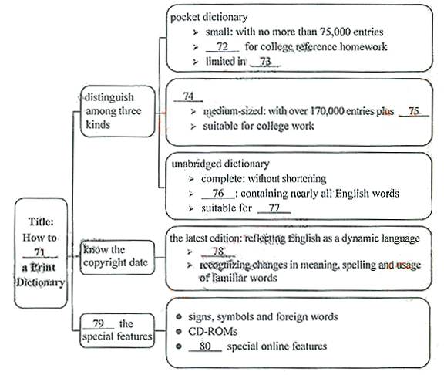

**71.Select 72.inadequate**

**73.wold information 74.desk dictionary**

**75.extra features 76.large and heavy**

**77.schools and libraries 78.admitting new words**

**79.check 80.access to**

**Section B (10 mark.)**

***Directions: Read the following passage. Answer the questions according to the information given in the passage.***

**Walk Out of the Comfort Zone and Try New Things**

For most high school students, free periods are useless. From what I have seen, few do homework; instead many are on their phones and talking, making it impossible for those who actually want to do work to complete any. As a senior next year, I think extra periods should be used to take optional subjects.

Our school offers many classes. Now is the time to experiment in different fields of study. We will never know if we are interested or talented in a subject if we don't try it.

In my 8th grade, I was told that I had to take an art class as a graduation requirement; so in the 9th grade I took Studio and Art. One of the projects was to build a clay pot, but I built mine incorrectly, so it broke in the kiln (窑). I found out that I have no artistic ability at all, and now I know for sure that I do not want to be an artist. However, the class was one of my favorites that year. I was able to try new activities and test my ability.

Walk out of our comfort zone and try new things! College is when we should focus on a specific major, but high school is when we have to figure it out.

Half of all college students change their major at some point. By doing that hundreds of dollars are wasted on classes that they would have never needed to take. So use our extra periods to find out what we want to do in college. The classes we choose can impact us in the future. Taking optional subjects will enrich our mind. It will also show colleges we are diverse students.

81. How should we use our extra periods in the author's opinion?

(No more than 9 words) (2 marks)

_________________________________________________________________________________________

82. Why does the author think we should experiment in different fields of study?

(No more than 17 words) (2 marks)

_________________________________________________________________________________________

83. Why did the clay pot show the author's lack of artistic ability?

(No more than 10 words) (3 marks)

_________________________________________________________________________________________

84.According to the author, how will taking optional subjects impact up in the future?

(No more than 13 words) (3 marks)

_________________________________________________________________________________________

**Section C (25 marks)**

***Directions:*** ***Write an English composition according to the instructions given below.***

请以老师当众表扬你为话题，用下面所给的句子开头，续写一篇英语短文。

|  |
| --- |
| As a student, I can tell you that there is nothing better than being praised by my teacher before my classmates. |

注意：

1. 将所有句子写在答题卡上；

2. **续写词数**不少于120个；

3. 不能使用真实姓名和学校名称。

**参考答案：**

**PartⅠ:**

**Section A**

1-5 ACBAA 6-10 BABCC 11-15 BCACB

**Section B**

16: Club 17: Monday 18: background 19: 5 pages 20: 750

**Part Ⅱ:**

**Section A**

21-25: BABDD 26-30: CACDA 31-35: CDCAB

**Section B**

36-40: DABAC 41-45: DCDBA 46-47: CB

**Section C**

48. if 49. the 50. and 51. shouldn't 52. more 53. with 54. how 55. you

**Part Ⅲ**

56-60 CBBDA 61-65 BDBAC 66-70 CACDA

**Part Ⅳ**

**Section A**

71. Select 72. inadequate 73. word information 74. desk dictionary 75. extra features

76. large and heavy 77. schools and libraries 78. admitting new words 79. check 80. access to

**Section B**

81. We should use them to take optional subjects.

82. We will never know if we are interested or talented in a subject without trying it.

83. It was built incorrectly and broke in the kiln.

84. It will enrich our mind and show colleges we are diverse students.

**Section C**

作文(略)

21

【答案】B

考点：考查强调句。

22.

【答案】A

【解析】

试题分析：一般将来时表示将要发生的动作或情况。在一般将来时的句子中，有时有表示将来时间的状语，有时没有时间状语，这时要从意思上判断是否指未来的动作或情况。句意：当你通读这本书的时候，你将会发现成千上万的经历过二战的每个人都有不同的经历。根据句意，判断主语的时态为一般将来时，故选A

【考点定位】考查时态。

23.

【答案】B

【考点定位】考查only置于句首的部分倒装。

24.

【答案】D

【解析】

试题分析：用作状语的从句叫状语从句。状语从句可置于句首、句末或句中，一般来说，状语从句都比较完整。但是，在一些状语从句中存在的省略问题，可以归纳为以下两点： 1. when, while, if, as if, although / though, as, until, once, whether, unless, where等引导的从句中，如果其谓语为be，而主语与主句的主语相同时，则从句的主语和be可省略。有时从句的主语为it时，也可省略it或从句中的有关成分。2. than, as, no matter what /who等后面成分的省略。句意：如果电子游戏落入一个错误的人手中就能够产生一个不良影响。

【考点定位】考查状语从句中的省略问题。

25.

【答案】D

【解析】

试题分析：一般过去时表示过去某个时间里发生的动作，常和表示过去的时间状语连用。此题主句的时态为一般过去时，表示这个事情和动作发生在过去，故从句时态也要用一般过去时。句意：我不能隐藏我的渴望，当我问道，“你现在希望我做些什么？”故选D

【考点定位】考查时间状语的时态。

26.

【答案】C

【考点定位】考查宾语从句。

27.

【答案】A

【解析】

试题分析：主谓一致指“人称”和“数”方面的一致关系。根据分析，第一空的谓语要填一个单数，因为此宾语从句：…that successa sum of…day.的主语是success，一个单数名词，故谓语要用is；后面的句子：oftenyears to achieve.的主语也是success，故第二空的谓语也是一个单数形式。句意：成功是将每天一小点努力积累起来，是需要多年的努力去达到，记住这些很重要。

【考点定位】考查主谓一致原则

28.

【答案】C

【考点定位】考查时态。

29.

【答案】D

【解析】

试题分析：根据分析，此句是一个非限制性定语从句，先行词是place，在定语从句中是作主语的，所以用关系代词引导。As引导非限定性定语从句时要放在句首，故排除，选用which。句意：这真是一个令人愉快的地方，这里的蜿蜒的小路和美丽的小村庄一定和100年前看起来是一模一样的。故选D

【考点定位】考查定语从句关系代词。

30.

【答案】A

【解析】

试题分析：伴随状语是指状语从句的动作伴随主句发生，它的特点是：它所表达的动作或状态是伴随着句子谓语动词的动作而发生或存在的。句意：当店员看到一张漂亮的脸上挤出一副抱歉的笑容时，她像扎根似的定在了那里，想着是去是留。此句的谓语动词是stood，所以wonder在此用ing形式作一个伴随状语。故选A

【考点定位】考查动词ing作伴随状语。

【名师点睛】本题旨在考查学生对于伴随状语的掌握，要求学生分辨的出什么是谓语，什么时候该用伴随状语

31.

【答案】C

【考点定位】考查祈使句。

32.

【答案】D

【解析】

试题分析：被动语态由“助动词be+及物动词的过去分词”构成。被动语态的时态变化只改变be的形式，过去分词部分不变。Hold back阻隔，隐瞒，句意：我非常想进去玩那些玩具，但是我被商店的玻璃阻隔了。根据句意，此句含有被动语态在里面，hold back要用被动语态，故选D

【考点定位】考查被动语态。

33.

【答案】C

【解析】

试题分析：A. If only要是…多好（if only常常用来表达强烈的愿望或遗憾，因此，主要用在虚拟语气中，用以表达强烈的愿望或非真实条件。常被译为“但愿”、“要是……该多好啊”等） B. After在…之后（用作连词是词，它引导的时间状语从句如果具有将来意义，往往要用一般现在时来表示(有时也用现在完成时)，而不能直接用一般将来时）C. Although虽然（表示“虽然”时，不要根据汉语习惯，在后面使用连词 but, 不过有时它可与 yet, still, nevertheless 等副词连用） D. In case万一，假使（引导条件状语从句）；句意：虽然那个工作要花大量的时间，但是许多学生都觉得经历是值得的。故选C

【考点定位】考查连词。

34.

【答案】A

【解析】

试题分析：talk over讨论，根据分析，可知act as a listening ear for fellow student to do sth中的to do sth是作student的宾语补足语。句意：有时我充当一个倾听者来倾听我的同学们讨论他们的烦心事。故选A

【考点定位】考查不定式作宾语补足语。

35.

【答案】B

【考点定位】考查if引导的条件状语。

**Section B (18 marks)**

***Directions: For each blank in the following passage there are four words or phrases marked A, B, C and D. Fill in each blank with the word or phrase that best fits the context.***

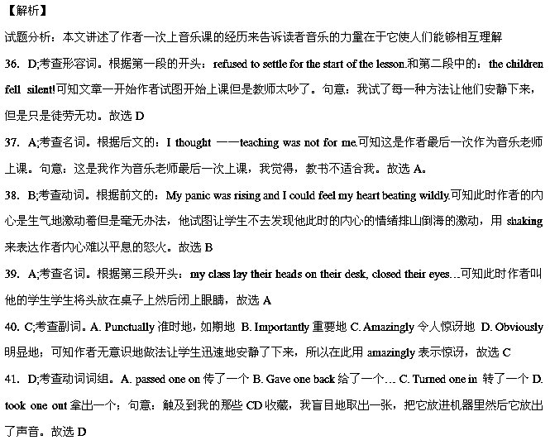42．C;考查动词。根据后文的：When the music started, the room was filled with the most beautiful tones and musical colors.可知当作者将音乐放进机器里，学生们趴在自己的桌子上静静地等着音乐响起来，故选C

43．D;考查动词。老师在放音乐，当然学生们都在听，listening放在此较其他选项都比较合适。故选D

44．B;考查名词。Raise sb’s head(s)抬起头来。句意：当音乐放完的时候，我要求他们所有人慢慢地抬起头来，那样的话，我们就可以一起分享我们的音乐之旅。故选B

45．A;考查动词。根据前文：At this point, when all the children were willing to share their experiences,可知学生们从开始的不愿响应作者到最后跟着作者一起参与其中，这让作者开始知道怎么教书了，故选A

46．C;考查形容词。A. unprepared为准备好的 B. unspoken无言的 C. unknown未知的 D. unforegotten难忘的；根据前文有the knowing已知的，又有and连接，可知横向上填unknown未知的，构成像前文tears and smiles那样的对比，形成对仗，故选C

47．B;考查名词。根据前文：The music allowed me to learn that teaching is about sharing and respect, tears and smiles, the knowing and the unknown and, most of all, an understanding of each other.可知这些都是音乐的好处，它让我们知道了分享和尊重，泪水和欢笑，已知与未知，最主要的是它让我们相互了解。所以最后一句作者旨在总结：这就是课堂音乐所拥有的力量

【考点定位】记事类短文阅读。

**Section C (12 marks)**

***Directions: Complete the following passage by filling in each blank with one word that best fits the context.***

【答案】

48．if

49．the

50．and

51．shouldn’t

52．more

53．with

54．how

55．you

【考点定位】科普类短文阅读。

**Part Ⅲ Reading Comprehension (30 marks)**

***Directions: Read the following three passages. Each passage is followed by several questions or unfinished .statements For each of them there are four chokes marked A. B. C and D. Choose the one that fits best according to the information given in the passage.***

**A**

【答案】

56．C

57．B

58．B

59．D

60．A

【考点定位】科普类短文阅读。

**B**

【答案】

61．B

62．D

63．B

64．A

65．C

【考点定位】科普类短文阅读。

**C**

【答案】

66．C

67．A

68．C

69．D

70．A

68．C;细节理解题。根据倒数第二段的第二句话可知Mrs.Byrnes没有时间在inspector来之前去洗所有的碗，所以她将所有的碗都丢进了烤箱避免被inspector发现。故选C

69．D;细节理解题。根据倒数第二段的倒数第三行：Mrs.Byrnes toss all the dishes into a big bread pan, covered them with a cloth, and stuck them in the oven.可知当inspector打开烤箱的时候他只会看到一块盖着布的某物，故选D

70．A;细节推理题。根据最后一段倒数第三行：After he steadied himself, he shook…可知inspector挥动着他的双手保持平衡。故选A

【考点定位】社会生活类短文阅读。

**Part IV Writing (45 marks)**

【答案】

71．Select

72．inadequate

73．word information

74．desk dictionary

75．extra features

76．large and heavy

77．schools and libraries

78．admitting new words

79．cheek

80．access to

【解析】

试题分析：本文讲述了三种字典的类型，旨在告诉读者如何根据需要去选择字典。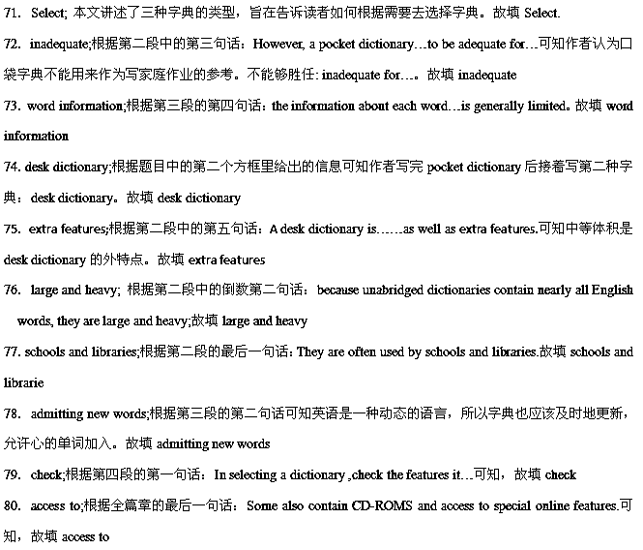

【考点定位】生活类短文阅读。

**Section B (10 mark.)**

【答案】

81.We should use them to take optional subjects.

82.We will never know if we are interested or talented in a subject without trying it.

83.It was built incorrectly and broke in the kiln.

84.It will enrich our mind and show colleges we are diverse students.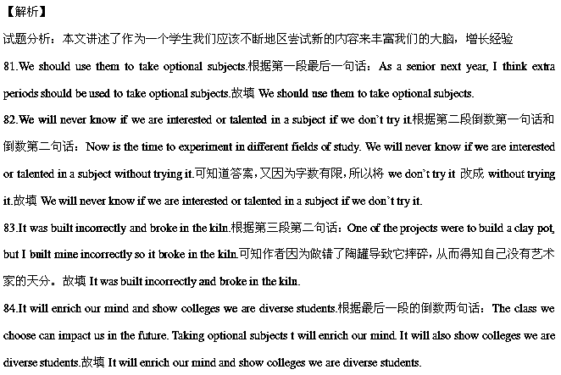

【考点定位】人生哲理类短文阅读。

**Section C (25 marks)**

***Directions:*** ***Write an English composition according to the instructions given below.***

请以老师当众表扬你为话题，用下面所给的句子开头，续写一篇英语短文。

|  |
| --- |
| As a student, I can tell you that there is nothing better than being praised by my teacher before my classmates. |

注意：

1. 将所有句子写在答题卡上；

2. **续写词数**不少于120个；

3. 不能使用真实姓名和学校名称。